ME480 HW1

Zhaoyi Jiang

**P1:**

solid model

facet normal 0.0 0.0 -1.0

outer loop

vertex 10.0 0.0 0.0

vertex 0.0 -10.0 0.0

vertex 0.0 0.0 0.0

endloop

endfacet

facet normal 0.0 0.0 -1.0

outer loop

vertex 0.0 -10.0 0.0

vertex 10.0 0.0 0.0

vertex 10.0 -10.0 0.0

endloop

endfacet

facet normal 0.0 -1.0 0.0

outer loop

vertex 10.0 -10.0 10.0

vertex 0.0 -10.0 0.0

vertex 10.0 -10.0 0.0

endloop

endfacet

facet normal 0.0 -1.0 0.0

outer loop

vertex 0.0 -10.0 0.0

vertex 10.0 -10.0 10.0

vertex 0.0 -10.0 10.0

endloop

endfacet

facet normal 1.0 0.0 0.0

outer loop

vertex 10.0 0.0 0.0

vertex 10.0 -10.0 10.0

vertex 10.0 -10.0 0.0

endloop

endfacet

facet normal 1.0 0.0 0.0

outer loop

vertex 10.0 -10.0 10.0

vertex 10.0 0.0 0.0

vertex 10.0 0.0 10.0

endloop

endfacet

facet normal 0.0 0.0 1.0

outer loop

vertex 10.0 -10.0 10.0

vertex 0.0 0.0 10.0

vertex 0.0 -10.0 10.0

endloop

endfacet

facet normal 0.0 0.0 1.0

outer loop

vertex 0.0 0.0 10.0

vertex 10.0 -10.0 10.0

vertex 10.0 0.0 10.0

endloop

endfacet

facet normal -1.0 0.0 0.0

outer loop

vertex 0.0 0.0 10.0

vertex 0.0 -10.0 0.0

vertex 0.0 -10.0 10.0

endloop

endfacet

facet normal -1.0 0.0 0.0

outer loop

vertex 0.0 -10.0 0.0

vertex 0.0 0.0 10.0

vertex 0.0 0.0 0.0

endloop

endfacet

facet normal 0.0 1.0 0.0

outer loop

vertex 0.0 0.0 10.0

vertex 10.0 0.0 0.0

vertex 0.0 0.0 0.0

endloop

endfacet

facet normal 0.0 1.0 0.0

outer loop

vertex 10.0 0.0 0.0

vertex 0.0 0.0 10.0

vertex 10.0 0.0 10.0

endloop

endfacet

endsolid model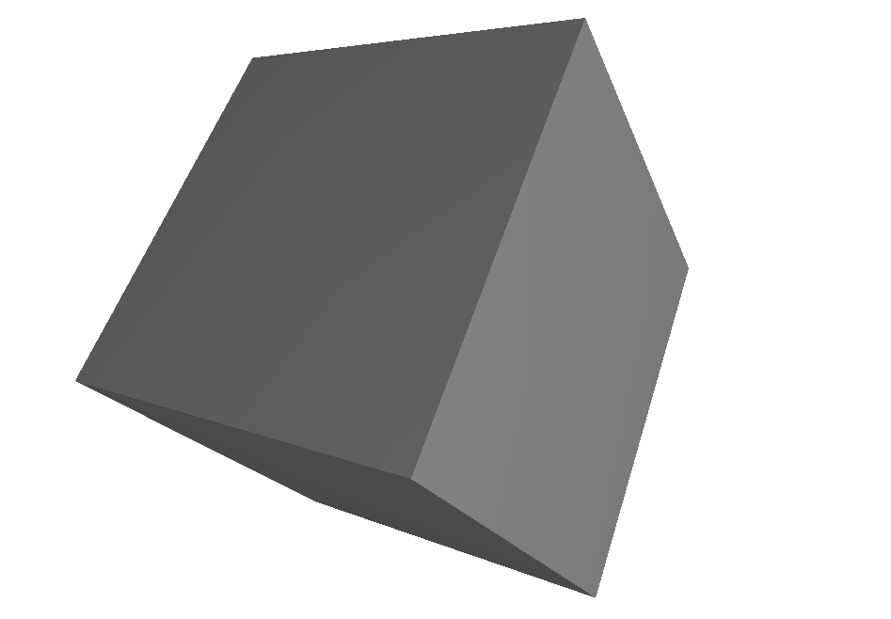

**P2:**

solid model

facet normal 0.0 0.0 -1.0

outer loop

vertex 5.0 0.0 0.0

vertex 0.0 -10 0.0

vertex 0.0 0.0 0.0

endloop

endfacet

facet normal 0.0 0.0 -1.0

outer loop

vertex 0.0 -10.0 0.0

vertex 10.0 0.0 0.0

vertex 10.0 -10 0.0

endloop

endfacet

facet normal 0.0 -1.0 0.0

outer loop

vertex 10.0 -10.0 10.0

vertex 0.0 -10.0 0.0

vertex 10.0 -10.0 0.0

endloop

endfacet

facet normal 0.0 -1.0 0.0

outer loop

vertex 0.0 -10.0 0.0

vertex 10.0 -10.0 10.0

vertex 0.0 -10.0 10.0

endloop

endfacet

facet normal 1.0 0.0 0.0

outer loop

vertex 10.0 0.0 0.0

vertex 10.0 -10.0 10.0

vertex 10.0 -10.0 0.0

endloop

endfacet

facet normal 1.0 0.0 0.0

outer loop

vertex 10.0 -10 10.0

vertex 10.0 0.0 0.0

vertex 10.0 0.0 10.0

endloop

endfacet

facet normal 0.0 0.0 1.0

outer loop

vertex 10.0 -10.0 10.0

vertex 0.0 0.0 10.0

vertex 0.0 -10.0 10.0

endloop

endfacet

facet normal 0.0 0.0 1.0

outer loop

vertex 0.0 0.0 10.0

vertex 10.0 -10.0 10.0

vertex 10.0 0.0 10.0

endloop

endfacet

facet normal -1.0 0.0 0.0

outer loop

vertex 0.0 0.0 10.0

vertex 0.0 -10.0 0.0

vertex 0.0 -10.0 10.0

endloop

endfacet

facet normal -1.0 0.0 0.0

outer loop

vertex 0.0 -10.0 0.0

vertex 0.0 0.0 10.0

vertex 0.0 0.0 0.0

endloop

endfacet

facet normal 0.0 1.0 0.0

outer loop

vertex 0.0 0.0 10.0

vertex 10.0 0.0 0.0

vertex 0.0 0.0 0.0

endloop

endfacet

facet normal 0.0 1.0 0.0

outer loop

vertex 10.0 0.0 0.0

vertex 0.0 0.0 10.0

vertex 10.0 0.0 10.0

endloop

endfacet

endsolid model

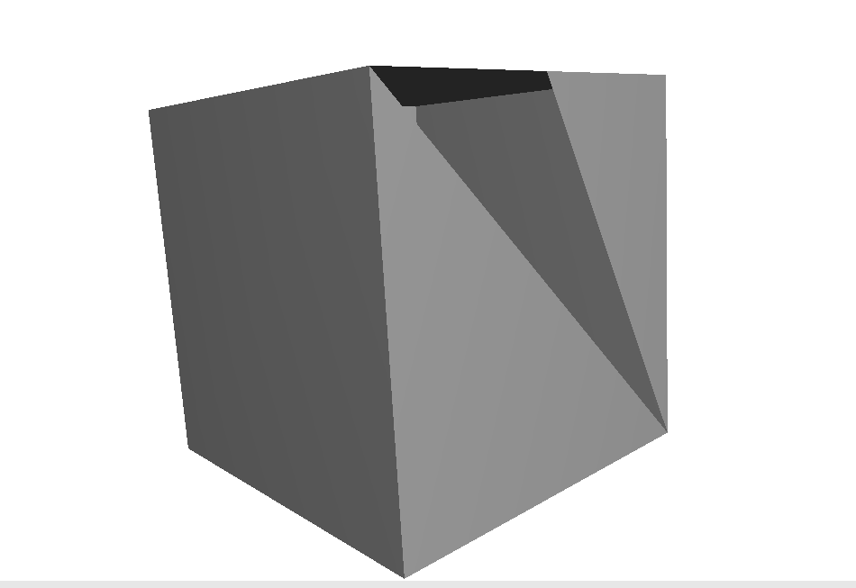

**P3:**

M140 S60

M105

M190 S60

M104 S230

M105

M109 S230

M82

G92 E0

G28

G90

G1 Z 2.0 F3000

G1 X10 Y10 Z0.3 F5000

G1 X20 Y10 Z0.3 F1500 E10

G1 X20 Y20 Z0.3 F1500 E20

G1 X10 Y20 Z0.3 F1500 E30

G1 X10 Y20 Z10.3 F1500 E40

G1 X20 Y20 Z10.3 F1500 E50

G1 X20 Y10 Z10.3 F1500 E60

G1 X10 Y10 Z10.3 F1500 E70

M140 S0

M107

G1 E-2 F2700

G1 E-2 Z15 F2400

G1 X0 Y200

M106 S0

M104 S0

M140 S0

M84 X Y E

M82

M104 S0

**P4:**

M140 S60

M105

M190 S60

M104 S230

M105

M109 S230

M82

G92 E0

G28

G91

G1 Z2.0 F3000

G1 X10 Y10 Z-1.7 F5000

G1 X10 F1500 E10

G1 Y10 F1500 E20

G1 X-10 F1500 E30

G1 Z10 F1500 E40

G1 X10 F1500 E50

G1 Y-10 F1500 E60

G1 X-10 F1500 E70

M140 S0

M107

G1 E-2 F2700

G1 E-2 Z15 F2400

G1 X0 Y200

M106 S0

M104 S0

M140 S0

M84 X Y E

M82

M104 S0

**P5:**

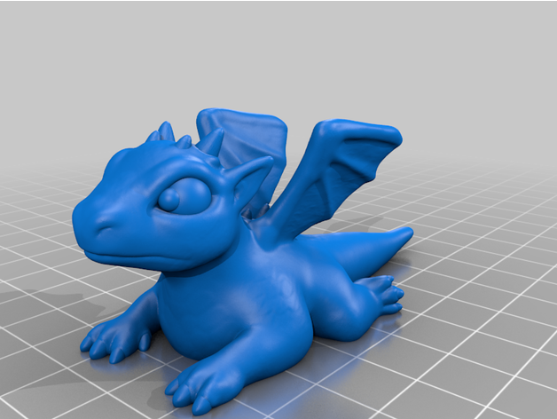

Pros: It has great strength on both normal and share directions since the supports are all triangles

Cons: The printing time and material usage are average, no significant advantage other than strength.

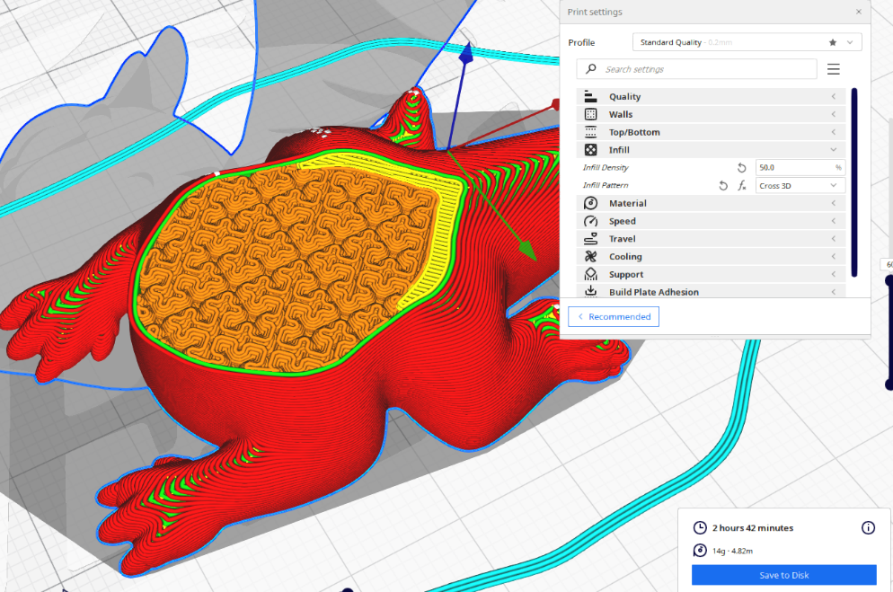

Pros: It saves material and reduces the weight of the model

Cons: It’s Time-Consuming and relatively weak on normal and share directions.

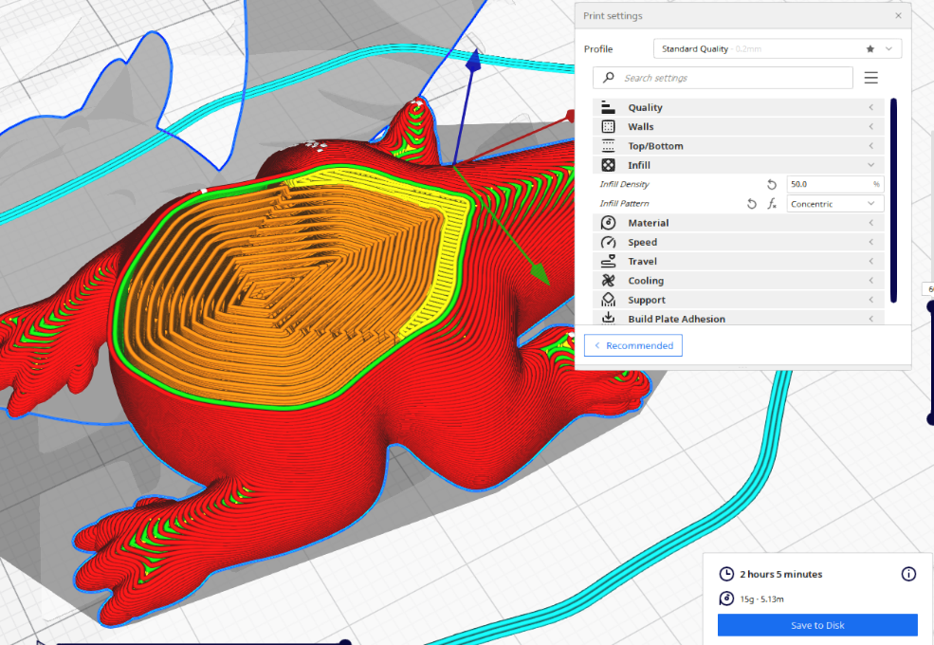

Pros: It’s faster compare to the other two infills and it saves some materials.

Cons: It’s not strong in share direction.